DAY 1: INRODUCTION TO NETWORKING AND IOS MODELTHEORY

- Install Wireshark on your laptop, start a capture on your main network interface, and visit any website (like instagram.com). Stop the capture and note down the protocol names you see in the packet list.
Answer
Steps to perform on your laptop
- Download and install Wireshark from the official site: https://www.wireshark.org
- Open Wireshark and select your main network interface (usually Wi-Fi or Ethernet).
- Click the blue shark-fin icon to start the capture.
- Open a browser and visit https://instagram.com (or any site).
- After a few seconds of page loading, stop the capture (red square button).
Protocols you will normally see in the packet list
When visiting an HTTPS site such as Instagram, the most common protocols that appear are:
- Ethernet – Layer-2 framing
- IP (IPv4 or IPv6)
- TCP – transport layer
- TLS (or SSL) – the encrypted HTTPS traffic
- DNS – domain-name lookups (before the connection is established)
- ARP – occasional address-resolution packets
- QUIC – sometimes used by modern browsers/sites instead of TCP+TLS
- HTTP/2 or HTTP/3 – may appear if Wireshark can decrypt the traffic (otherwise it stays as TLS)
You will not see clear-text HTTP for Instagram because the site forces HTTPS.
If you want, paste a few lines from your packet list (Protocol column) and I can help you interpret them.

- Pick any 3 packets from your Wireshark capture and identify which OSI layer each packet mainly represents (for example, HTTP for Application layer, TCP for Transport layer, etc. Use the Protocol column and Info details in Wireshark to help you map protocols to OSI layers.

Answer
Packet Breakdown & OSI Layer Mapping
- Packet 1: DNS Query / Response (dns)
  - Primary OSI Layer: Layer 7 — Application Layer
  - Role: Resolves domain names (like instagram.com) into IP addresses so your computer knows where to send requests. It provides services directly to network-aware applications (such as your web browser).
- Packet 2: TCP Handshake SYN (tcp)
  - Primary OSI Layer: Layer 4 — Transport Layer
  - Role: Manages end-to-end communication, port numbers, reliable delivery, and connection setup (using the TCP 3-way handshake) between your laptop and the remote web server.
- Packet 3: ARP Request / Reply (arp)
  - Primary OSI Layer: Layer 2 — Data Link Layer
  - Role: Resolves an IP address to a local physical hardware address (MAC address) on your local network segment so frames can be delivered across local switches.
How to Verify in Wireshark
When you click on any packet in the top Packet List pane, look at the middle Packet Details pane:
- Frame: Shows physical interface details (Layer 1 - Physical).
- Ethernet II: Shows MAC addresses (Layer 2 - Data Link).
- Internet Protocol Version 4/6: Shows source/destination IP addresses (Layer 3 - Network).
- Transmission Control Protocol / User Datagram Protocol: Shows source/destination ports (Layer 4 - Transport).
- Domain Name System / TLS / HTTP: Shows application-specific payload protocols (Layer 7 - Application).

- Create a colorfull diagram of the OSI Model using any drawing tool (MS Paint, Canva, or even paper and upload a photo). For each layer, add a real-world example from apps you use daily (e.g., WhatsApp uses the Application layer, Instagram images use the Presentation layer, etc.).
Answer
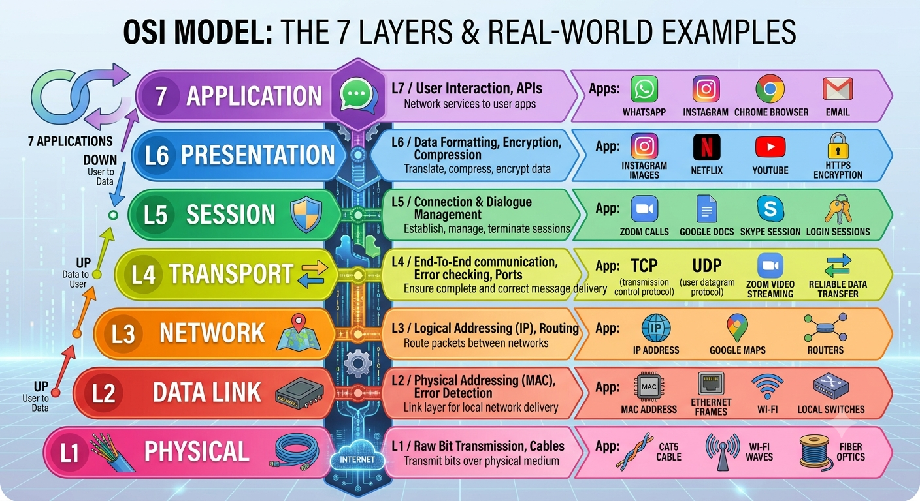

- Explain how sending a message on WhatsApp travels through at least 4 layers of the OSI Model, describing what happens at each layer in your own words. Think about how your message is typed, packaged, sent over the internet, and received.
Answer
1. Application Layer (Layer 7)
What happens:
You type “Hey, are you there?” in WhatsApp and hit send. At this layer, WhatsApp formats your message into a structured data packet (often JSON or XML) and adds app-level headers like sender ID, timestamp, and recipient ID.wireshark+1
Real-world analogy:
Like writing a letter, putting it in an envelope, and addressing it.

2. Transport Layer (Layer 4)
What happens:
Your message is handed to TCP (WhatsApp uses TCP for reliability). TCP breaks the message into segments, adds sequence numbers, and ensures it will be reassembled correctly on the other side. It also manages flow control and error checking.wireshark
Real-world analogy:
Putting your letter into numbered envelopes so the recipient knows the order.

3. Network Layer (Layer 3)
What happens:
Each TCP segment is wrapped in an IP packet. Your phone’s OS adds source and destination IP addresses (yours and WhatsApp’s server). Routers across the internet use these IPs to forward the packet toward the recipient.oneuptime
Real-world analogy:
The postal service reading the address and routing your letter through sorting centers.

4. Physical Layer (Layer 1)
What happens:
The IP packets are converted into electrical signals (over WiFi or cellular radio waves) and transmitted through the air or cables to the nearest cell tower or router. This is the actual “wireless” or “wired” transmission.deepwiki
Real-world analogy:
The truck or plane physically carrying your letter to the destination city.

